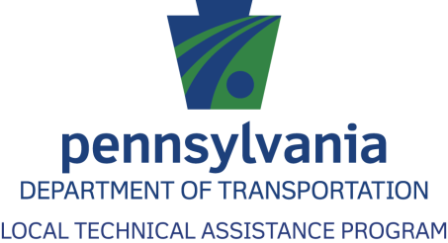BD10308_

**Salt and Snow**

**Management Webinar**

# Pennsylvania Local Technical Assistance Program (LTAP)

Pennsylvania Department of Transportation

Bureau of Planning and Research

400 North Street, 6th Floor

Harrisburg, PA 17120

Phone: 1-800-FOR-LTAP E-mail: ltap@state.pa.us

717-787-5243 Web Site: www.ltap.state.pa.us

FAX: 717-783-9152

**The Pennsylvania Local Technical Assistance Program (LTAP) shares transportation knowledge, improves road maintenance and safety skills, and puts research and new technology into practice at the local level through:**

**Training:** Workshops are scheduled throughout the state and can be requested as a road show.

**Technical Assistance:** LTAP technical experts are available by phone, by email, and in person to help townships troubleshoot specific issues on their roadways.

**Newsletter:** LTAP distributes a quarterly newsletter, *Moving Forward*, which features the latest news and new practices and technologies.

**Technical Information Sheets:** Tech sheets provide useful, technical information on such topics as effective stop sign placement, how to use the MUTCD, paving roads, and other safety and maintenance issues related to local roads.

**Website:** LTAP’s website, www.ltap.state.pa.us, is a valuable tool that provides up-to-date information on workshops, news items, LTAP Advisory Committee members, tech sheets, newsletters, and other resources.

***All LTAP services are offered at NO Cost to Municipalities!!!***

# Roads Scholar I Program - Professional Certification Program

* Must complete 10 approved workshops within a three-year period
* Pass (70%) an in-class 12 question quiz taken at the end of each workshop
* Successful completion of an approved CPR training is equal to 1 workshop credit.

# Roads Scholar II Program - Professional Certification Program

* Must complete 8 approved workshops within a three-year period
* Pass (70%) an in-class 12 question quiz taken at the end of each workshop
* Successful completion of an approved CPR training is equal to 1 workshop credit.

Introduction & Goals

Winter storm conditions can disrupt the daily lives of our citizens such that wintery road conditions can slow travel leading to delays, accidents, property damage, and even human injury. The cost of maintaining snow and ice covered roadways continues to rise while the expectations of the traveling public for safe and passable roads increases. This combination of winter storm conditions, rising motorist expectations, and the cost of providing a higher level of winter roadway services creates increased challenges for State and municipal road crews.

Much research on effective and efficient use of road salts and winter storm management practices has been performed at the state, national, and international levels. New and improved winter storm fighting methods, materials, and equipment have a substantial impact on meeting the demands of the motorist while providing for safer travel during winter storm events.

The Goal of this training is to provide Pennsylvania municipalities a better understanding of the salt bidding process, PennDOT Winter Traffic Services Agreements, and how to survive when salt supplies are low.

# Mission:

**“To provide safe, passable roadways throughout Pennsylvania municipalities during winter storm events as efficiently as possible.”**

Pennsylvania has the 5th largest state highway system in the United States. This high road mileage combined with Pennsylvania’s geographic location within the snow belt place a heavy strain on PennDOT’s available winter service resources. During winter storms, the focus is on maintaining the interstates and expressways. In a normal storm event winter services are typically provided on a 2 hour cycle. However, the heavier the storm and more traffic on the roads takes longer to provide this service. Other major roadways can take 3 to 5 hours to complete a cycle. The ability to provide safe and passable roads on the secondary highway system diminishes as traffic and storm intensity increases.

PennDOT’s primary goal is to provide passable roads that are as safe as possible.

PennDOT Winter Traffic Services Agreements

Municipal governments service their streets and secondary roadways at the local level enabling residents to enter the state highway system. However, there is a need for municipal governments to partner with PennDOT to provide winter traffic services for certain state roadways, including bridges with their approaches, on the State Highway system within the municipality having a goal to provide safe and unimpeded flow of vehicular traffic over these State Highways.

# Three Options to Partner with PennDOT

****There are three primary options for a municipality to partner with PennDOT to provide Winter Traffic Services on State Highways within their municipality:

1. Agility Winter Service Exchange
2. Winter Traffic Services Standard Agreement with Lump Sum Annual payments
3. Winter Traffic Services with Actual Cost Reimbursement

## 1) Agility Winter Service Exchange

An agility agreement is essentially an equally valued trade of services. Typically, the municipality will plow snow, spread anti-skid and/or salt, anti-ice pavements, or remove snow on State Highways during the winter in exchange for maintenance activities provided by PennDOT during the summer, such as pavement surface treatments, line painting, road repair, and more. Since there is an upfront agreement on the value of exchanged services provided by each party, there is no exchange of money in this type agreement.

### Terms of the Agility Agreements Include:

* The agreement is for a five-year period.
* One three-year renewal can be agreed upon by a Renewal Notification Letter.
* The activities provided by the municipality must equal in value to the activities provided by PennDOT.
* Services exchanged shall follow PennDOT 408 Specifications, Highway Foreman Manual, and other applicable PennDOT publications.

## 1) Agility Winter Service Exchange Cont.

### The Agility Agreement contains the following Attachments:

* Attachment A is the Terms and Conditions statement
* Attachment B is a Categorized List of Service
* Attachment C is a SAMPLE Renewal Notification
* Attachment D is Contract Provisions with regard to the Right to Know Law 8-K1532

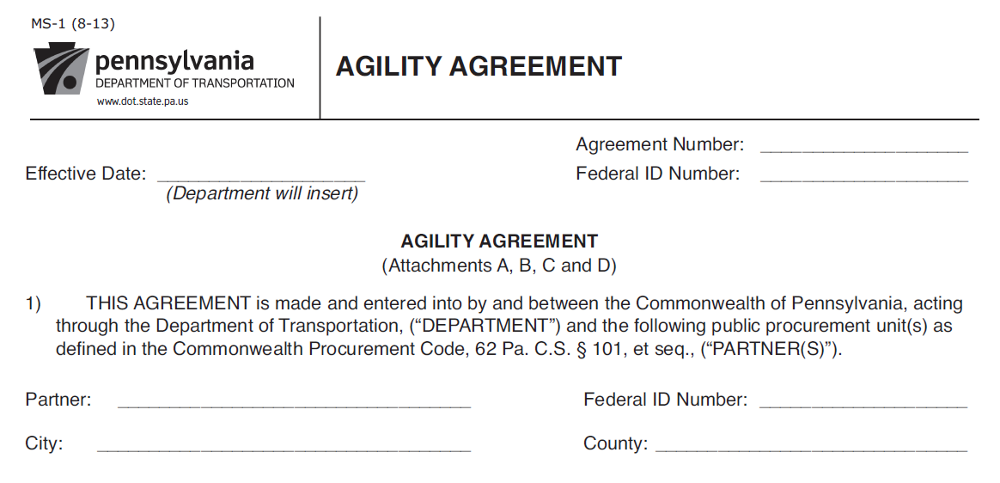

## 1) Agility Winter Service Exchange Cont.

The services exchanged in an Agility Agreement are outlined in a separate “Agility Work Plan.” This “Work Plan” is used to document the scope of work and to place a value on the service exchange so that the total cost provided by each party balances. The work plan is signed off by PennDOT, the Partner and AFSCME.

Line item services are documented when approved by the receiving party for accountability purposes.

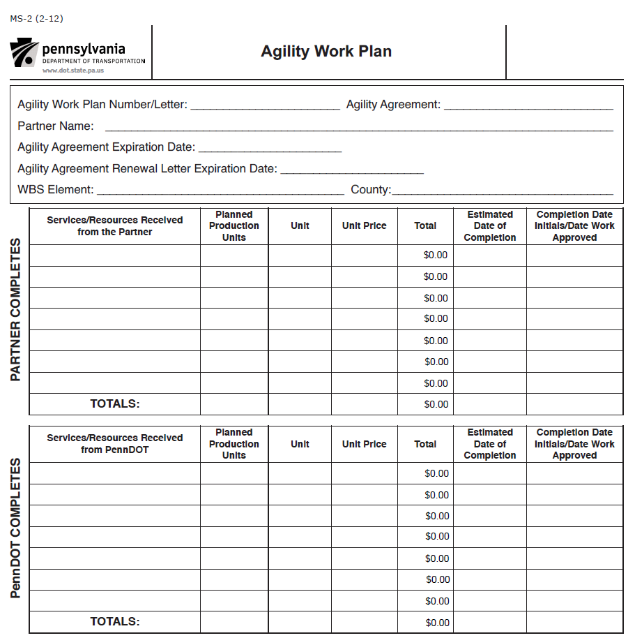

## 2) Winter Traffic Services Standard Agreement with Lump Sum Annual Payments

PennDOT encourages municipal governments to enter into its Standard Winter Traffic Services Agreement where the Department reimburses the municipality based upon established lump sum rates as determined on a County and Highway Maintenance Functional Class basis. These agreements are for a term of five (5) consecutive winter seasons. Municipalities that want to establish or renew a winter service agreement should contact their PennDOT district maintenance office by July 31.

Under the terms of the agreement, the municipality will agree to furnish winter traffic services for the period of October 15 to April 30 of each winter season. The work is for an agreed upon amount, during the term of the agreement, regardless of the amount of work required. The amount is payable to the municipality in a lump sum paid on or before November 15 of the preceding winter.

In the event of a severe winter, the agreement has a condition that provides for a cost adjustment tied to a percentage of PennDOT’s costs above a five-year average for the county the services are provided in. There is a $1,000 deductible for agreements totaling $5,000.01 or more and a $500.00 deductible for all others. This payment adjustment is made at the end of the year.

The Commonwealth of Pennsylvania has implemented a Strategic Environmental Management Program, and as part of this program has established a Green Plan Policy. The Green Plan Policy is designed to protect the environment, conserve resources, and comply with environmental laws and regulations. PennDOT had issued its own “Green Plan Policy Statement.”

## 2) Winter Traffic Services Standard Agreement with Lump Sum Annual Payments Cont.

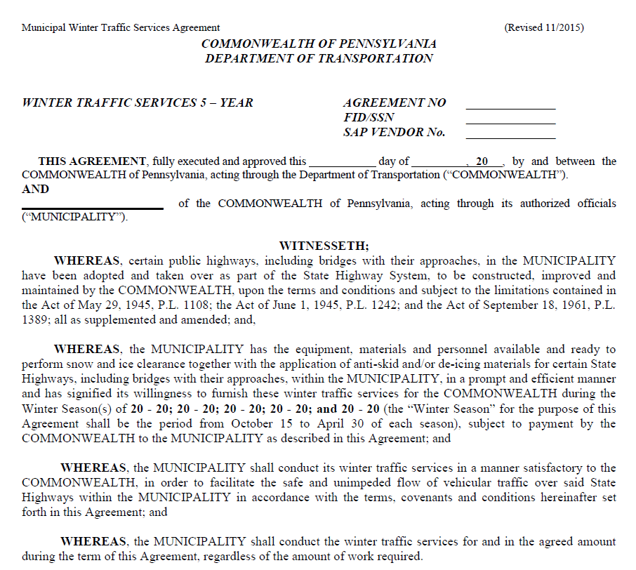

## 2) Winter Traffic Services Standard Agreement with Lump Sum Annual Payments Cont.

### The Green Plan Policy

* Follow PennDOT Specifications & Manuals
* Practice Sensible Salting
* Environmental Awareness
* Employee Training

Municipalities are required to perform all work in accordance with applicable PennDOT specifications and policies and procedures set forth in the PennDOT Highway Maintenance Foreman Manual, and the PennDOT Maintenance Manual. By following these requirements, municipalities are encouraged to practice sensible salting techniques to keep costs down for the municipality. By employing these practices, the municipality may expend less than the lump sum agreement amount that PennDOT agrees to pay. **Sensible salting is encouraged to be consistent with the** **Commonwealth’s Green Plan Policy to protect the environment, conserve resources, and comply with environmental laws and regulations**. Municipalities are to ensure their employees are committed to protecting the environment and are properly trained about the environmental impacts of their work.

## 3) Winter Traffic Services with Actual Cost Reimbursement

The terms of the Actual Cost Agreement are the same as the Standard Agreement; however the method of reimbursement is different. Under this mechanism, PennDOT will pay an upfront lump sum equal to the Standard Agreement amount, and then will reimburse municipalities up to $1,800 per lane mile to cover their actual costs. Municipalities must keep track of their costs under this option. However, if the actual cost is less than the standard lump sum reimbursement, PennDOT will deduct the difference from the following winter season’s upfront payment.

To be eligible for the Actual Cost Reimbursement, the municipality must document all eligible costs for labor, equipment, materials and overhead on PennDOT’s “Summary of Municipal Agreement Costs” form. This form is submitted to PennDOT at the end of the winter season for payment adjustment.

This agreement is a good option for municipalities that are experiencing increased development and a high expectation from the public for more responsive winter road maintenance along state highways.

Sensible Salting

Sensible Salting is a key to accomplishing our mission: “To provide safe, passable roadways throughout Pennsylvania municipalities during winter storm events as efficiently as possible.” Not only will sensible salting save on winter maintenance costs, it results in a more environmentally friendly operation.

Safe passable roadways are free of as much ice and snow pack as is practical and can be traveled safely by motorists at reasonable speeds. This does not mean they are returned to dry pavement or wet pavement which is free of all snow, sleet, and ice from shoulder to shoulder. **Look at sensible salting practices by using the “Rule of Right.”**

Sensible Salting

follows the “Rule of Right:”

The RIGHT amount of

The RIGHT material at

The RIGHT time

# Sensible Salting Cont.

PennDOT issued its own “Green Plan Policy Statement” which commits to protecting the environment, preventing pollution, and using resources efficiently.

# Benefits for Municipality and PennDOT

* Improved winter traffic services for residents
* Balance of workforce and equipment resources
* Municipality has direct control of services provided
* Sensible salting techniques saves money and are environmental friendly
* Municipalities may only purchase salt from an awarded supplier in the county the municipality is located in

In summary, a municipality typically has the necessary snow removal equipment and workforce available to service their own roads. By including winter traffic services on nearby State Highways, the municipality can provide more responsive access to the state highway system for their residents. By utilizing municipal crews to perform winter traffic services on both local and State highways within the municipality, resources are optimized between the Municipality and PennDOT while the municipality has the ability to control the winter traffic services being provided within their borders.

By learning and using sensible salting techniques, the municipality can save money when servicing both local and State highways. As a secondary benefit the winter operations will be more sensitive to impacting the environment with excess use of salt or anti-skid material. Remember – the Standard Winter Traffic Services Agreements are for a lump sum amount. The municipality has the ability through efficient and effective operations to stretch resources and perhaps result in some profit with these agreements.

DGS Statewide Sodium Chloride Contract

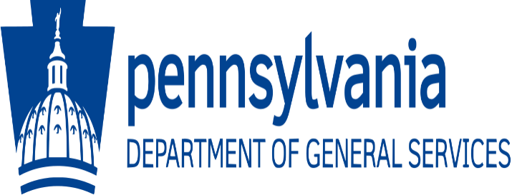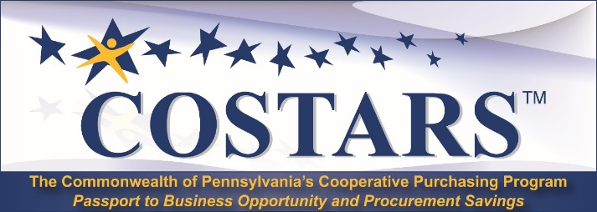

The Pennsylvania Department of General Services purchases road salt through a Statewide Sodium Chloride contract. This is a commonwealth-wide cooperative sourcing contract for road salt that is used by PennDOT, other state agencies, and is available to municipalities that are members of COSTARS. This follows the philosophy of making a very large quantity purchase for the result of a lower price. For municipalities; the contract allows a wide range between the estimated quantity and the quantity that can be purchased at the bid price; and, it eliminates the entire material bidding process for the municipality.

COSTARS which stands for Cooperative Sourcing to Achieve Reductions in Spend is the Commonwealth of Pennsylvania’s Cooperative Purchasing Program, a service provided by the Pennsylvania Department of General Services for local procurement entities within the Commonwealth. This purchasing process is in conformance with state procurement law that provides the statutory authority for Member entities to engage in cooperative purchasing with the Commonwealth. Eligible procurement entities include: any political subdivision; any public authority; and many other tax-exempt and non-profit public entities that become COSTARS members.

The benefits of COSTARS membership include cost savings due to volume purchasing; convenience of using state contracts to purchase goods by simply issuing a purchase order; flexibility and variety of using a pool of suppliers; and having available free workshops and a quarterly newsletter to assist members in using state contracts.

Additional savings to the municipality are accrued due to DGS taking on the responsibility for developing materials specifications, advertising, printing, mailing and bid evaluation.

# DGS Statewide Sodium Chloride Contract Cont.

Steps for the municipality to register for the Department of General Services Statewide Contract for Sodium Chloride (Road Salt) include:

1. Register online to become a COSTARS Member
2. Complete the Salt Contract Participation Agreement including estimated material quantity (simple one-page form completed on-line)
3. Salt contracts are County Specific
4. **Enrollment for participation in the Pennsylvania Statewide Sodium Chloride Contract opens the first business day of January and extends through March 15 for participation in the coming winter season.**
5. Department of General Services advertises the sodium chloride contract for bids after March 15
6. Awarded contracts are posted in early August

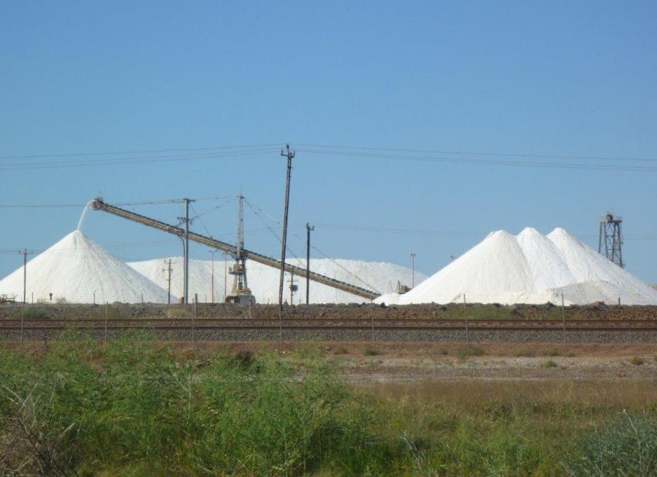**Note:** Road Salt meets PennDOT Requirements therefore; liquid fuel money can be used for this materials purchase.

*By participating in the DGS Statewide Sodium Chloride contract, municipalities have flexibility in “locking-in” their salt supply for the entire winter season with a 40% buffer on both the high and low side of their estimated order.*

# DGS Salt Contract Terms & Conditions

## Supplier Requirements:

* 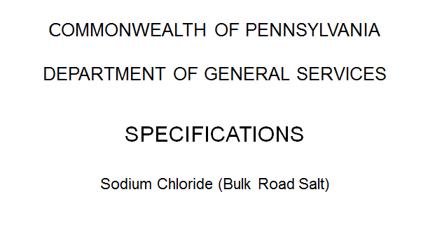The Contract is effective no earlier than August 1 and expires July 31 of the following year.
* Supplier bids are broken into one lot per county, and DGS awards the lowest qualified bidder on a county by county basis.
* Pricing is the same for initial fill and balance of season fills. (Municipalities may not pick up salt at the supplier’s stockpile.)
* All bidders must provide materials from an approved source listed in PennDOT Publication 35 (Bulletin 15), meeting Publication 408 Specification Requirements of Section 722 – Sodium Chloride.
* PennDOT will perform random testing of this material to verify quality.

## DGS/COSTAR Member Requirements:

Municipalities may only purchase salt from an awarded supplier in the county the municipality is located in.

The Salt Contract Participating Agreement is a legally binding agreement; however, the purchasing entity is only obligated to purchase 60% of the total tons ordered in the agreement, and they can purchase up to 140% of the submitted amount at the contracted price. A member participant can review and/or edit their participation agreement up to the enrollment deadline.

If the tonnage purchased by all COSTARS participants for a single supplier equals at least 100%, the supplier may not charge storage fees for any specific COSTARS member that did not take 60% of their estimated quantity.

The **Initial Fill** period is from August 1 to October 31 for deliveries within 30 days of receipt of the order. The initial fill delivery quantity is 150 tons per day unless the total estimated quantity is less than 150 tons. The minimum contract order for the season is 22 tons per stockpile.

**NOTE:** All COSTARS members are encouraged to take at least 60% of their estimated quantity during the initial fill period. Orders cannot exceed the stockpile capacity.

## DGS/COSTAR Member Requirements Cont.:

The **Balance of Season - Winter Fill** period for orders is from November 1 through July 31. The minimum order is 22 tons per stockpile, and the minimum delivery is 175 tons per day unless the order is less than 175 tons. Orders cannot exceed the stockpile capacity.

If a COSTARS member does not order the estimated tons during the initial fill period, those tons will be available through the end of the contract period.

All orders are placed directly with the correctly awarded supplier, and the municipality is responsible to pay the supplier directly for all quantities purchased.

If a state of emergency or disaster is declared by the Governor, the supplier is expected to attempt to provide continuous twenty-four hour service as directed by the Commonwealth in any county that an emergency or disaster is declared.

# DGS Salt Contract Results 2016-2017

# 

This map reveals the results of competitive bidding for the DGS Sodium Chloride Contract. As mentioned earlier, the municipality must purchase road salt from the successful supplier for the county that the municipality is located in. Prices vary from county to county, but this is mostly due to the cost of transporting the salt from designated distribution centers.

# Estimating Quantities

## How much salt do you need for a season??

* For a start, review historical records for the past five-year running average.
* Adjust this number if new mileage will be added such as new streets or participation in a PennDOT Winter Traffic Services agreement.
* Consider any changes in your winter maintenance approach such as using 100% salt or adding pre-wetting or anti-icing to increase the level of service.
* Also take into consideration the possibility of unseasonably cold or stormy weather trends. Remember that many low accumulation storms are typically treated with chemicals vs. deep plowing storms that use less chemical.
* Never reduce your material projections with the hopes that the winter will be milder.

## Delivery Strategies

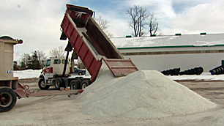Ideally, it is best to receive 100% of the estimated salt order during the initial fill, as long as storage capacity is available. This eliminates the challenges of restocking when there are back-to-back storms, during an emergency or disaster declaration, or other heavy demand periods that may delay the timely delivery of road salt.

There are many considerations in receiving your salt deliveries to make sure the process is efficient and that the order can be dropped off and appropriately received by a designated municipal representative:

* If possible, have the salt unloaded directly into the storage facility. If necessary, dumping of salt should be on an impervious surface for ease of loading into the storage facility.
* Have the delivery area clear of equipment and obstructions. Delivery trucks range from 48 to 55 feet in length and need room to maneuver.

## Delivery Strategies Cont.

* Dump beds can rise as high as 30 feet above ground. When laying out your storage building(s), keep in mind the location of overhead wires and lights.
* If the storage facility is hard to find, place signs or provide maps to the truckers.
* Always arrange to have a municipal representative present when the delivery is anticipated in order to accept and authorize deliveries.
* Post names and contact information at the stockpile for individuals authorized to receive salt deliveries.

When receiving a salt delivery, the truck should be tarped to prevent loss of salt during transport and to keep the salt dry.

The individual responsible for receiving the delivery must have safety training to avoid injury during the delivery process!

Strategies for Low Salt Supplies

Pennsylvania is one of the snow belt states; and when considering, its extensive state and local highway system, its Keystone State location, and its economic importance to the northeastern United States; Pennsylvania faces a tremendous challenge in winter storm fighting to provide safe and passable roads to the traveling public. Key to providing winter traffic services is the use of sodium chloride or rock salt. In order to ensure adequate supplies both PennDOT and Municipalities must have a plan.

# Backup Strategies

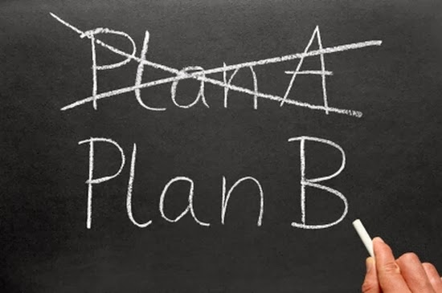We can predict long term weather forecasts, but there are surprises. Some winter seasons take a turn for the worst requiring much more salt and anti-skid materials than planned for. Suppliers may not be able to keep up with demand leaving the supplier unable to meet all orders. In severe weather the supplier may not be able to deliver due to shortages of drivers, trucks, and/or passable roads. The list of hardships can go on!

PennDOT cannot dictate how or who the municipality purchases its salt from, but there are options:

* COG’s and Co-Ops may find better prices for initial fills but alternative sources or a backup plan must be set up for unforeseen events.
* PennDOT encourages municipalities to use the DGS Statewide Sodium Chloride Contract. This agreement does address resupply of road salt at the purchase price as long as the quantities are within the agreed upon variances of the estimated contract quantities (40% + or – of the estimated quantity).

## If all else fails, municipalities may be able to borrow salt from PennDOT.

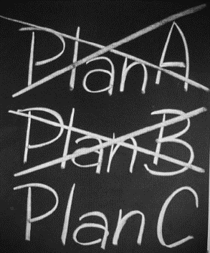In order to borrow salt from PennDOT, the municipality must have a contract in place with a salt supplier that will ensure the borrowed salt will be replaced as soon as the municipality receives its delivery. The municipality may not replace salt with anti-skid. Salt conservation measures are expected, and the salt on loan must be resupplied to PennDOT as soon as possible. PennDOT may only accept resupplies of salt that had been purchased through an approved vendor/manufacturer listed in PennDOT Publication 35 (Bulletin 15.).

## If all else fails, municipalities may be able to borrow salt from PennDOT Cont.

Procedures have been set up for borrowing salt:

* The municipality should contact its County Emergency Management agency and provide the following:
* Tons of salt on hand
* Estimate how long it will last (number of storms)
* Whether salt is on order (supplier and quantity ordered)
* Expected date of back-order delivery
* Tons requested from PennDOT
* Number & size of trucks available for pick up
* Possible pickup times
* Contact information and municipality’s location
* County Emergency Management will contact PEMA
* PEMA State Emergency Operations Center contacts PennDOT Area Command which in turn contacts the PennDOT District Office
* PennDOT District Office determines if adequate supply is on hand, including the location of the supply
* PennDOT Area Command returns information to PEMA with approval or non-approval
* PEMA will notify municipality of PennDOT’s decision and, if approved, provide directions for pickup
* PennDOT will also coordinate with the PA Turnpike, if necessary, to find out if it has sufficient quantities to loan out

Keep in mind that PennDOT’s supplies may be running low as well, so Plan C may not be an option!

# Preventing Salt Shortages

In summary, there are alternatives available in the salt purchasing process that afford the municipality flexibility in maintaining a source of salt supply, even in a severe winter. Sensible salting techniques will stretch salt supplies while saving costs and protecting the environment. As a last option, a municipality may be able to borrow salt from PennDOT, provided that PennDOT has adequate supplies available. It is best not to rely on this option due to the risk of PennDOT not being able to service its own roads with adequate salt supplies.

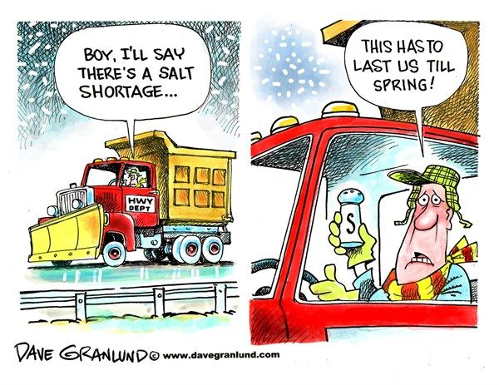

For More ASSISTANCE...

Call: 1-800-FOR-LTAP

Write: LTAP – Local Technical Assistance Program

Pennsylvania Department of Transportation

Bureau of Planning and Research

400 North Street, 6th Floor

Harrisburg, PA 17120

E-mail: [LTAP@state.pa.us](mailto:LTAP@state.pa.us)

Web Site: www.ltap.state.pa.us